

**Semester Two**

**Examination 2017**

**Question/Answer booklet**

**MATHEMATICS**

**SPECIALIST UNITS 1 & 2**

**Section One:**

**Calculator-free**

|  |
| --- |
| Student Name: _____________________________________ |
| Teacher’s Name: _____________________________________ |
|  |

**Time allowed for this section**

Reading time before commencing work: five minutes

Working time for paper: fifty minutes

**Material required/recommended for this section**

**To be provided by the supervisor**

This Question/Answer booklet

Formula Sheet

**To be provided by the candidate**

Standard items: pens (blue/black preferred), pencils (including coloured), sharpener, correction tape/fluid, erasers, ruler, highlighters

Special Items: nil

**Important note to candidates**

No other items may be taken into the examination room. It is **your** responsibility to ensure that you do not have any unauthorised notes or other items of a non-personal nature in the examination room. If you have any unauthorised material with you, hand it to the supervisor **before** reading any further.

**Structure of this paper**

|  |  |  |  |  |  |
| --- | --- | --- | --- | --- | --- |
|  | Number of questions available | Number of questions to be attempted | Working time (minutes) | Marks available | Percentage of exam |
| **Section One**  **Calculator—free** | **7** | **7** | **50** | **51** | **35** |
| Section Two  Calculator—assumed | 13 | 13 | 100 | 99 | 65 |
|  | | | |  | 100 |

**Instructions to candidates**

1. The rules for the conduct of Western Australian external examinations are detailed in the

*Year 12 Information Handbook 2017.* Sitting this examination implies that you agree to abide by these rules.

1. Answer the questions according to the following instructions.

**Show all your working clearly.** Your working should be in sufficient detail to allow your

answers to be checked readily and for marks to be awarded for reasoning. Incorrect answers given without supporting reasoning cannot be allocated any marks. For any question or part question worth more than two marks, valid working or justification is required to receive full marks. If you repeat an answer to any question, ensure that you cancel the answer you do not wish to have marked.

It is recommended that you **do not use pencil**, except in diagrams.

1. You must be careful to confine your responses to the specific questions asked and to follow any instructions that are specific to a particular question.
2. Spare pages are included at the end of this booklet. They can be used for planning your responses and/or as additional space if required to continue an answer.

* Planning: If you use the spare pages for planning, indicate this clearly at the top of the page.
* Continuing an answer: If you need to use the space to continue an answer, indicate in the original answer space where the answer is continued, i.e. give the page number. Fill in the number of the question that you are continuing to answer at the top of the page.

1. The Formula Sheet is **not** handed in with your Question/Answer Booklet.

# Section One: Calculator–free 35% (50 marks)

This section has **seven (7)** questions. Attempt **all** questions. Write your answers in the spaces provided.

Spare pages are included at the end of this booklet. They can be used for planning your responses and/or as additional space if required to continue an answer.

* Planning: If you use the spare pages for planning, indicate this clearly at the top of the page.
* Continuing an answer: If you need to use the space to continue an answer, indicate in the original answer space where the answer is continued, i.e. give the page number. Fill in the number of the question(s) that you are continuing to answer at the top of the page.

Working time: 50 minutes

**Question 1 (6 marks)**

One thousand young people were surveyed regarding their participation in swimming(S), athletics(A) and chess(C).

Assume that everyone participated in at least one of those activities.

n(S) = 310, n(A) = 650, n(C) = 440, n(S **∩** A) = 170, n(S ∩ C) = 150, n(A ∩ C ) = 180,

(a) How many people participated in all three activities? (2 marks)

(b) State n(S ∩ C ∩ A′). (1 mark)

A smaller group were asked about their participation in Football (F) and Basketball(B).

(c) If n(F ∩ B) = 30, n(F ∩ B′) = 10, n(F′ ∩ B′) = 6 and n(U) = 50, determine:

(i) n(F ∪ B) (1 mark)

(ii) n(B) (2 marks)

**Question 2 (5 marks)**

(a) The equation 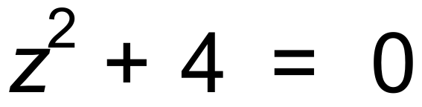 has 2 complex roots.

(i) Verify that z = 2i is one of the roots. (1 mark)

(ii) State the other root. (1 mark)

(b) Determine the roots of this equation:

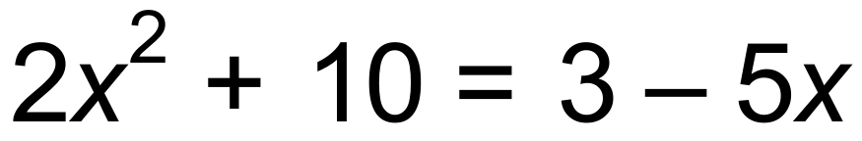 (3 marks)

**Question 3 (8 marks)**

A line of Pascal’s triangle is shown below.

|  |  |  |  |  |  |
| --- | --- | --- | --- | --- | --- |
| 1 | 5 | 10 | 10 | 5 | 1 |

With reference to that line, demonstrate the truth ( or otherwise) of these general statements.

(a) (i) 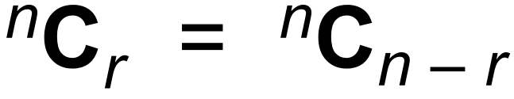(2 marks)

(ii) 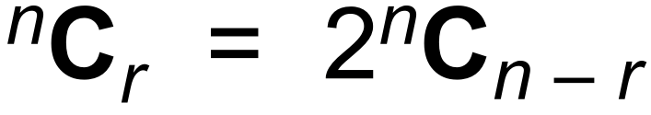 (2 marks)

(b) Harry has 5 tyres (one of these is a spare kept in the boot) for his car. None of the five is particularly good, and he decides to replace 3 of them.

(i) In how many ways can he select three tyres to be replaced? (2 marks)

(ii) Once he has replaced the three tyres with new ones, in how many ways can

they be put onto his wheels, given that one of the old ones will be put into the boot

as a spare. (2 marks)

**Question 4 (12 marks)**



The line joining A to B is dilated by scale factor 4 parallel to the *y* axis, and also dilated with scale factor 5 parallel to the *x* axis. This is an example of *y* = *f* (*x*) being transformed to *y* = ***p*** f (***q*** *x* ).

(a) Determine the values of ***p*** and ***q***. (2 marks)

After both dilations mentioned above have been applied, images are produced.

The images of A and B are called A′ and B′ respectively.

(b) Determine the equation of line A′B′. (1 mark)

(c) Calculate the co-ordinates of A′ and B′. (2 marks)

(d) State one matrix which would transform A and B into A′ and B′. (2 marks)

(e) State one matrix which would transform A′ and B′ into A and B. (2 marks)

(f) What geometric transformation applied to a function, say *g*(*x*), would be equivalent

to using matrix  ? (2 marks)

(g) Matrix  is applied to A, B and C. (1 mark)

State the value of the area of triangle A′B′C′ in terms of m, n, r and s.

**Question 5 (8 marks)**

Consider the function 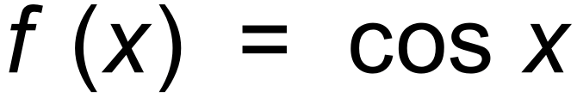.

(a) On the axes below, sketch the graph of 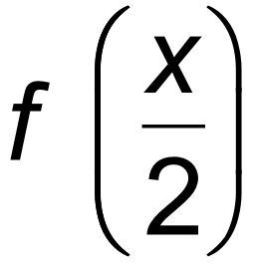 . (2 marks)

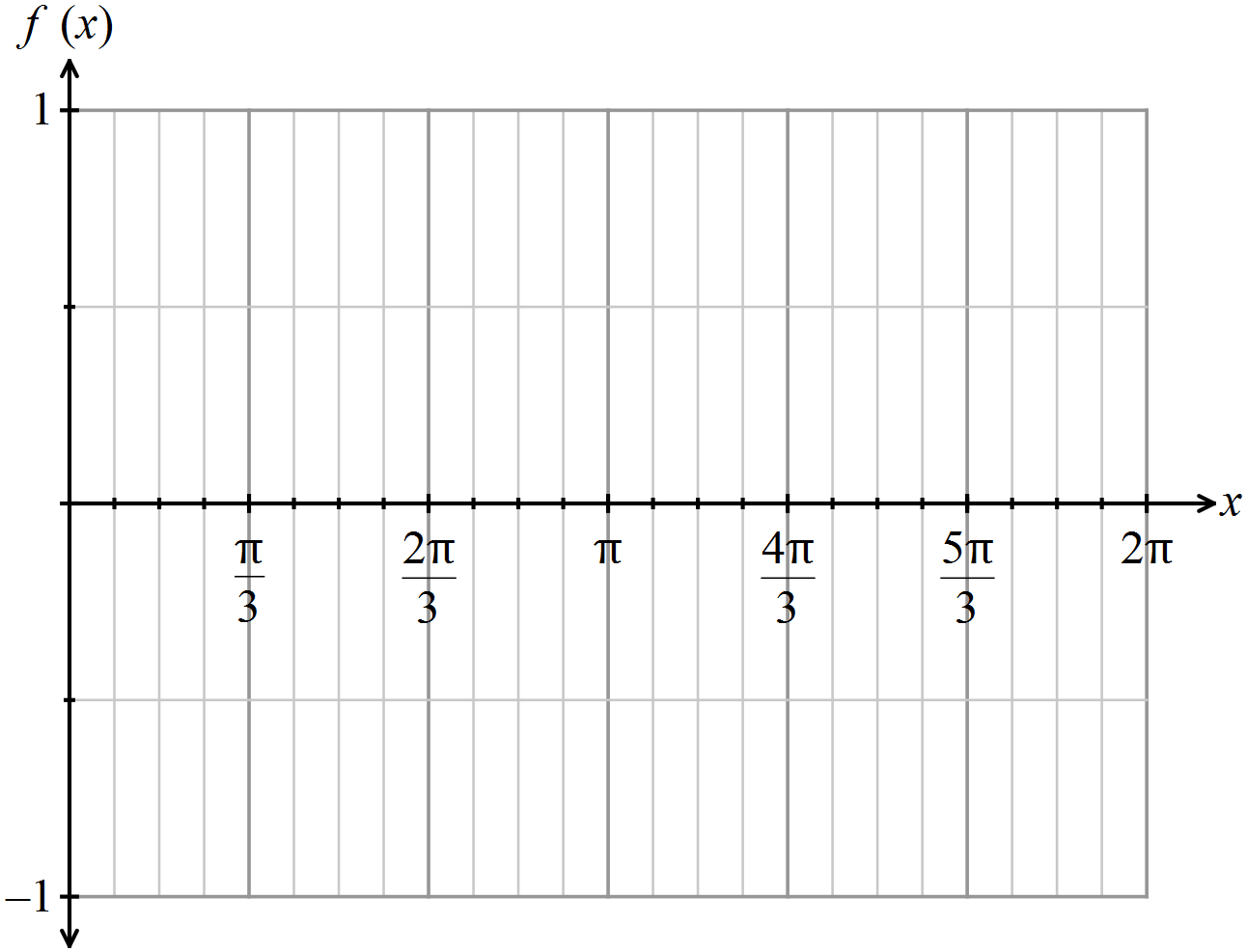

The graph can be used to solve the equation 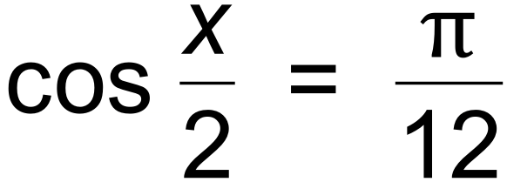 for 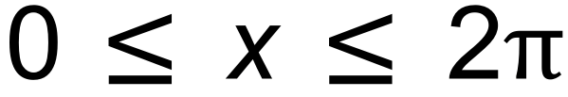 .

(b) Draw the appropriate line on the axes above and determine the solution to the equation,

correct to a reasonable degree of accuracy. (3 marks)

(c) Simplify, giving your answers in terms of A sin Bx or A cos Bx, A, B  .

(i) 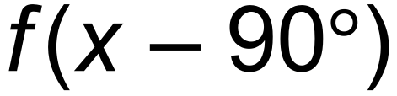 (1 mark)

(ii) 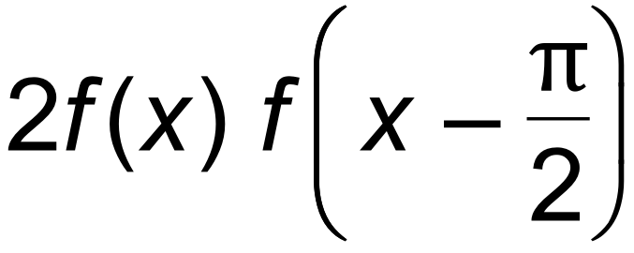 . (2 marks)

**Question 6 (7 marks)**

(a) Use direct proof to show that the sum of 5 consecutive odd numbers is a multiple of five.

Your answer needs to be supported by reasoning. Do not just give examples. (3 marks)

(b) 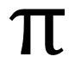 is a well known irrational number. Prove by contradiction that − is irrational. (4 marks)

**Question 7 (5 marks)**

Use mathematical induction to prove $∀ n ∈N$ then 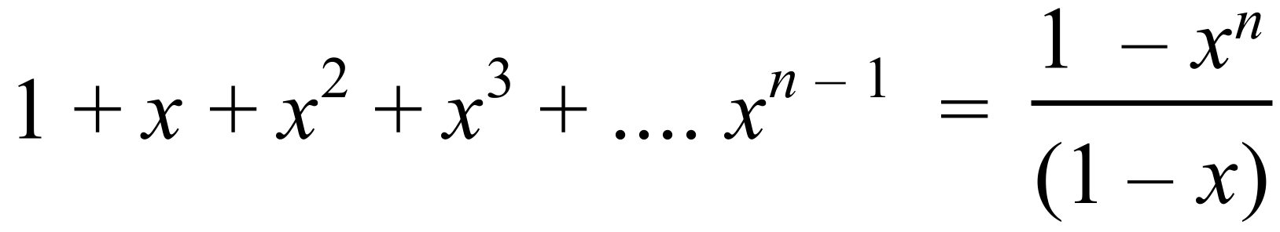 (5 marks)

**End of Questions**

**Additional working space**

Question number(s): ……………………

**Additional working space**

Question number(s): ……………………